Docker May 11th

* docker run -dit imagename

docker run -dit –name imagename -p 70:80 httpd -v volume1:/usr/local/apach2/htdocs

* docker search ubuntu
* docker pull centos
* docker images
* docker ps , docker ps -a
* docker stop containerid
* docker start containerid
* docker rm containerid {to remove container}
* docker rmi imagename {to remove image}
* docker stats
* docker exec -it containerid /bin/bash {to login inside the container}
* docker login
* docker commit containerid dockerusername/nameforimage {to create a snapshot of container}
* docker push

March 12th

* docker run -dit –name_for_container dockerhost_-p portno:application_portno service_name
* ex- docker run -dit --name container_name -p 70:80 httpd
* in the above dockerhost portno can be anything but since the application is httpd we enabled 80 port
* docker run -dit --name dev_jenkins -p 81:8080 jenkins/Jenkins
* we should enable the docker host portnumber the value on left side 81,70 in the security groups, docker hosts will redirect any request to 81 to Jenkins and 70 to httpd

Docker data directory is located in /var/lib/docker/overlay2/hash-id-of-container/merged

n

This folder is same the folder / in the machine after you login inside the container which means

/folder of container = /var/lib/docker/overlay2/hashid/merged

Docker inspect container-id gives you the hash id of container

Two ways of giving non root users the permissions to run the docker commands is

1. giving the non root user sudo permissions to execute the /bin/docker commands in suoders folder(/etc/sudoers) {raj ALL=(ALL) NOPASSWD:ALL}
2. Adding the users to a docker group <https://docs.docker.com/engine/install/linux-postinstall/>

May 17th

docker run -dit –name imagename -p 70:80 httpd -v volume1:/usr/local/apach2/htdocs

we attach a persistent volume to the container to avoid accidental deletion of application data and to maintain the size of container as minimum as possible

this volume created is mounted in /var/lib/docker/volumes/volume1/_data

May 19th

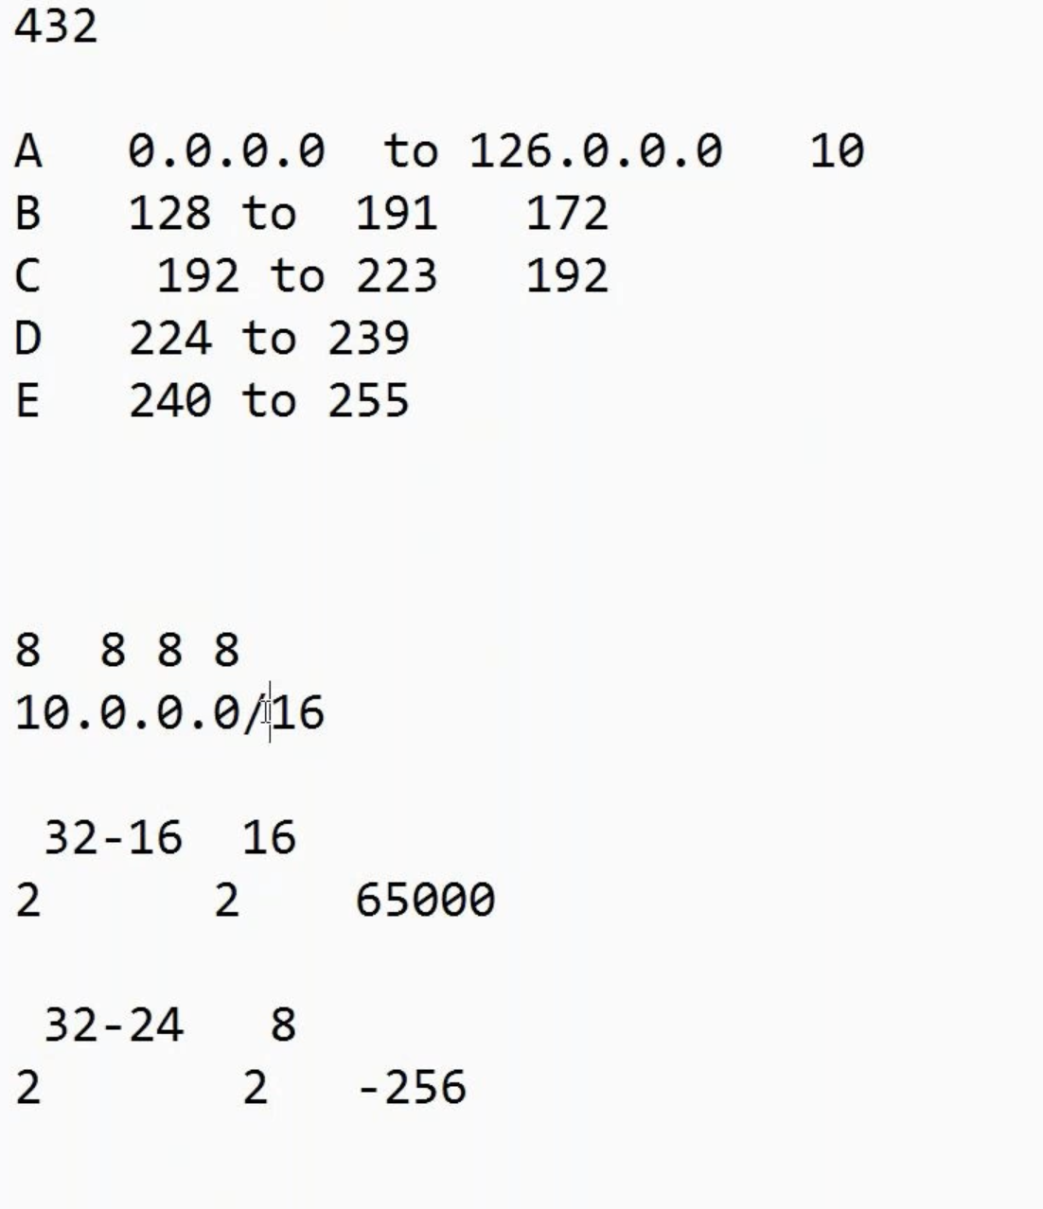

10.0.0.0, 172.0.0.0, 192.0.0.0 are the private ip series

10.0.0.0/16 = number of ips that we can provide is 2^32-16 = 65000 ips

10.0.0.0/24 = 2^32-24 = 256 ips

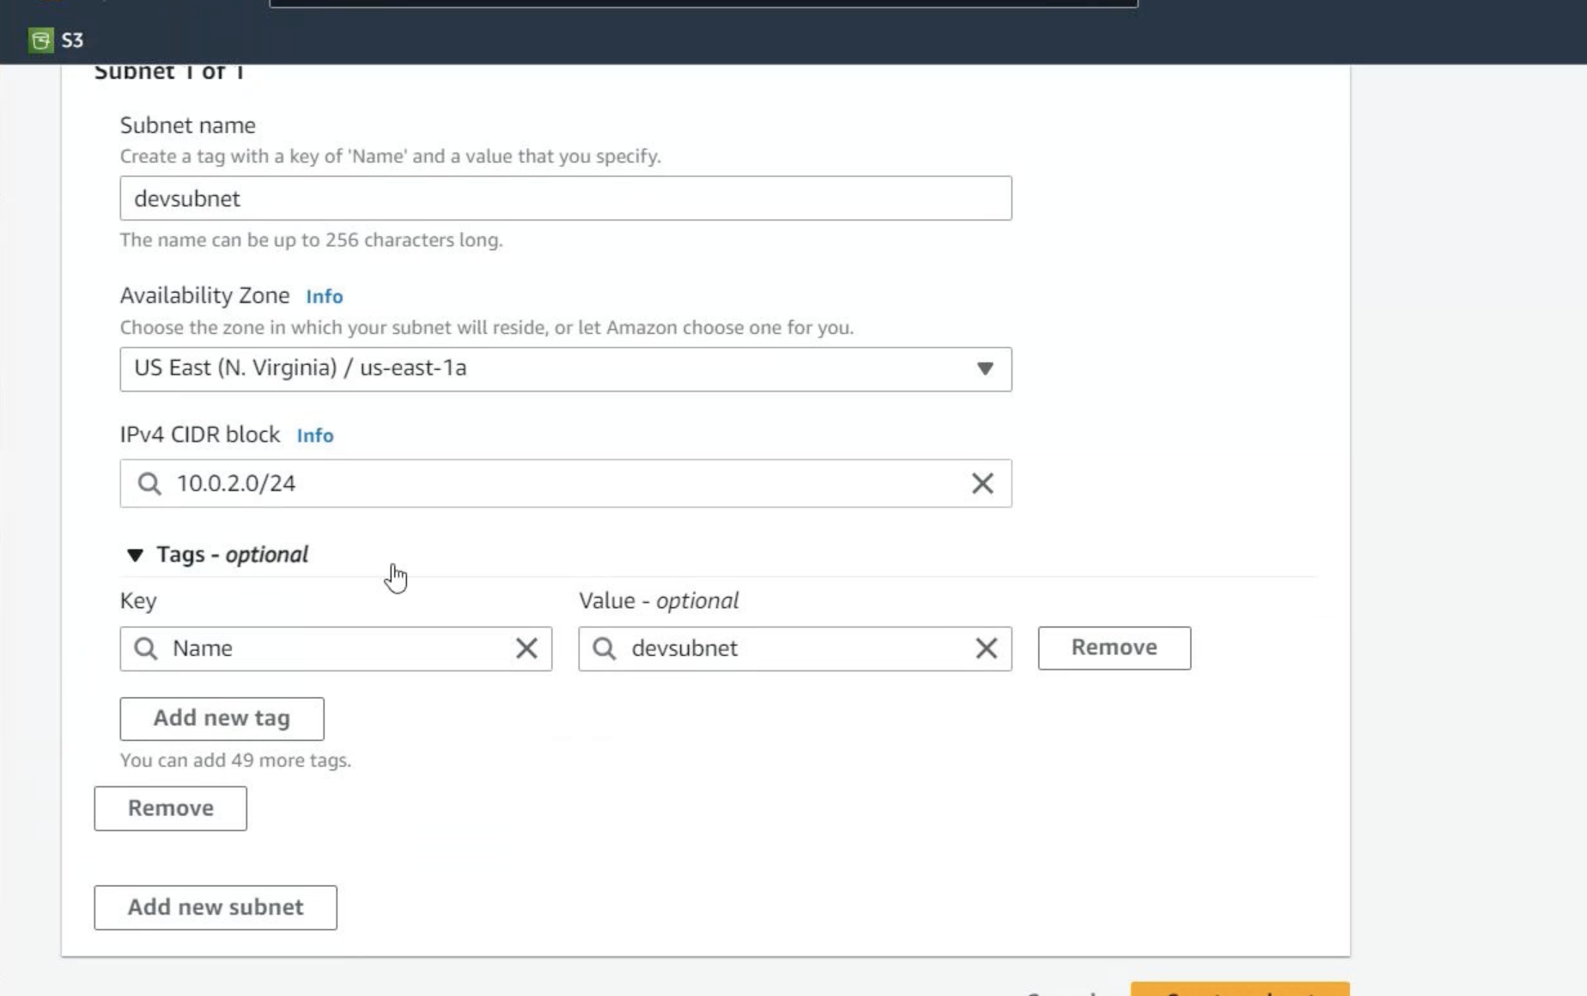

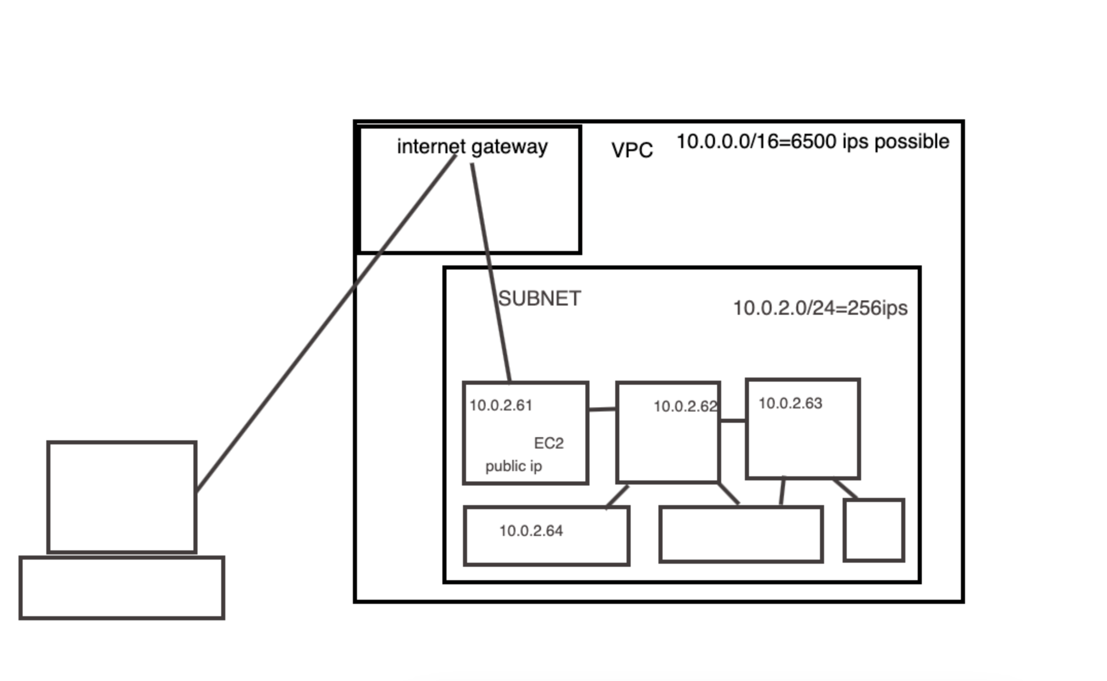

Only few servers have public ip enabled for security purposes so our machine connect to that server which has the webpages and is connected to the backend servers in the same network through internet gateway

May 22nd

Docker network ls

Three types of. Networks

1. Bridge network – host ip and docker container ips are diff range
2. Host network – host ip eth0 and docker0 ips are same
3. None network – no network for the containers

> Docker network ls {gives network ids)

Docker0 default ip range 172.17.0.0/16

>Docker network inspect network-id

Gives how many containers created in that network which can also be seen in the docker inspect container-id

May 23rd

Dockerfile:

Dockerfile is a simple text file that consists of instructions to build Docker images.

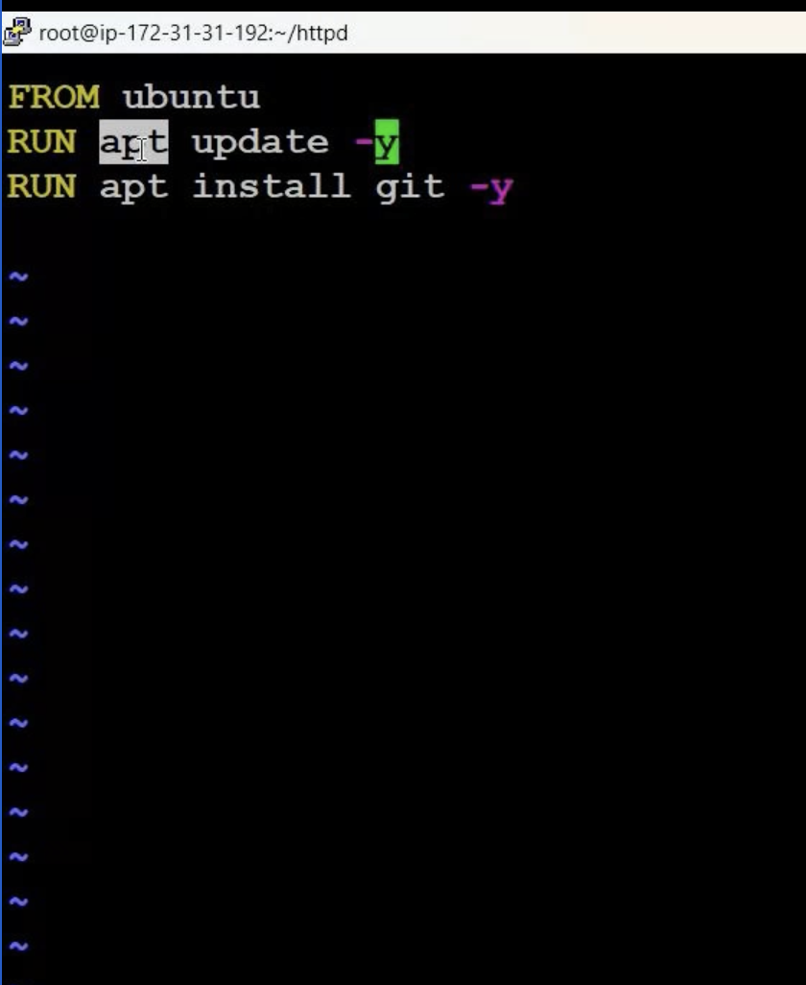 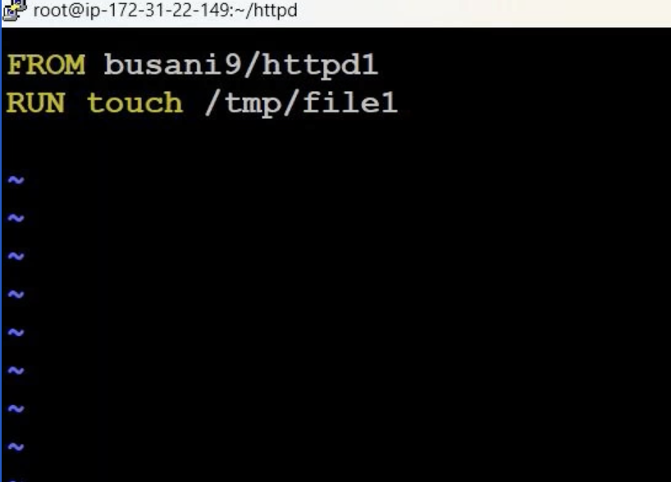

Created a directory and create a file name Dockerfile D is cap

>vi Dockerfile

>docker build . -t name_for_image {this will run the Dockerfile created in project directory}

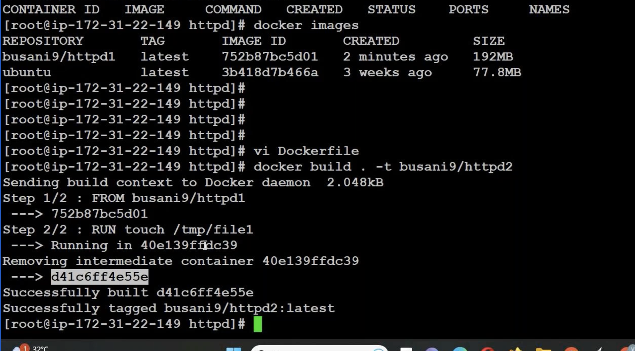

Instructions inside Dockerfile

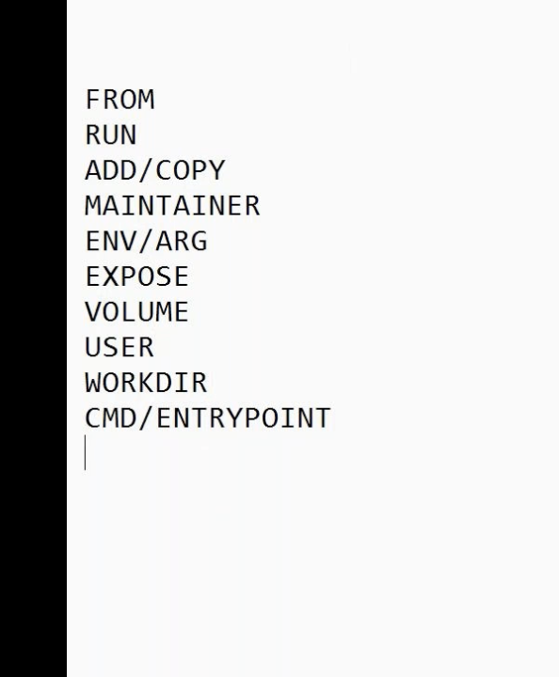

Making amar as default user instead of root user login inside containers

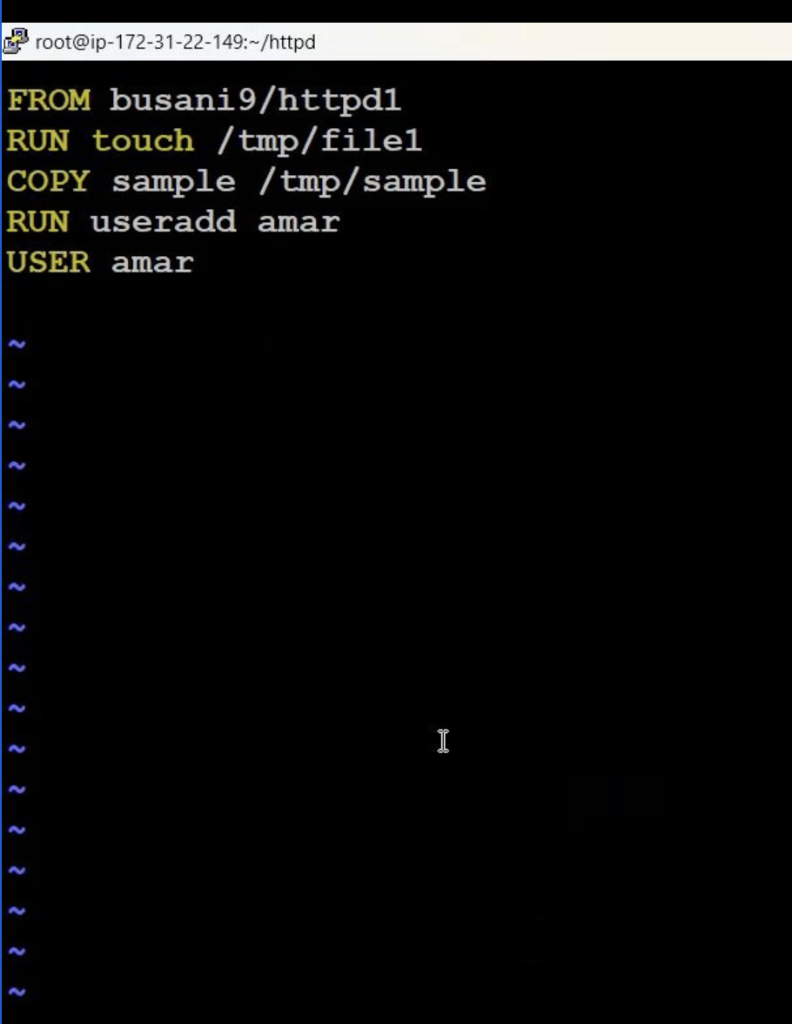 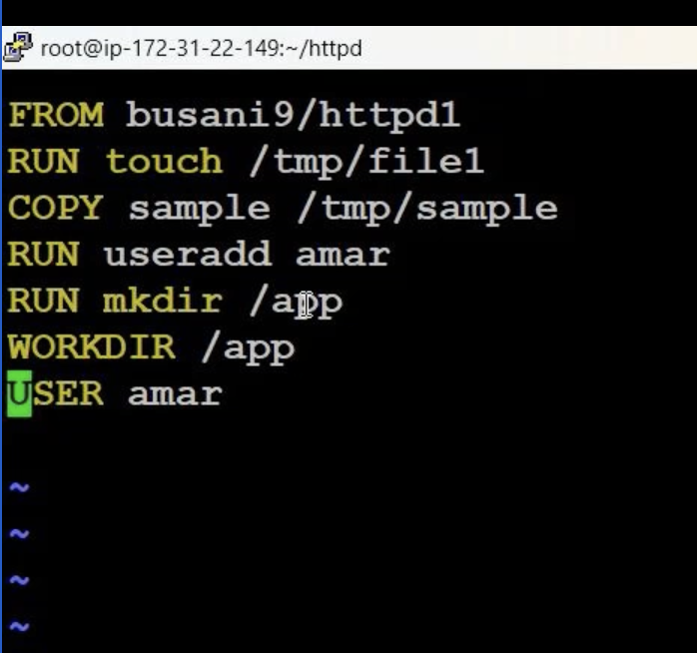

ADD Vs COPY

COPY only supports the basic copying of local files into the container, while ADD has some features (like local-only tar extraction and remote URL support) that are not immediately obvious. Consequently, the best use for ADD is local tar file auto-extraction into the image, as in ADD rootfs.tar.xz / .

How to remove all containers in 1 go

>Docker ps -aq | xargs docker stop | xargs docker rm

* Docker network ls

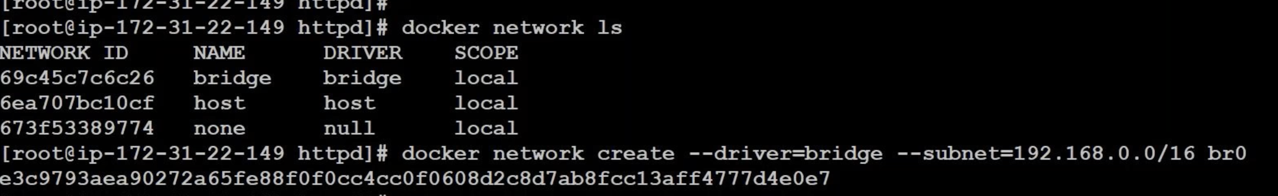

Attach a new image to a new network instead of default 172.17.0.0/16

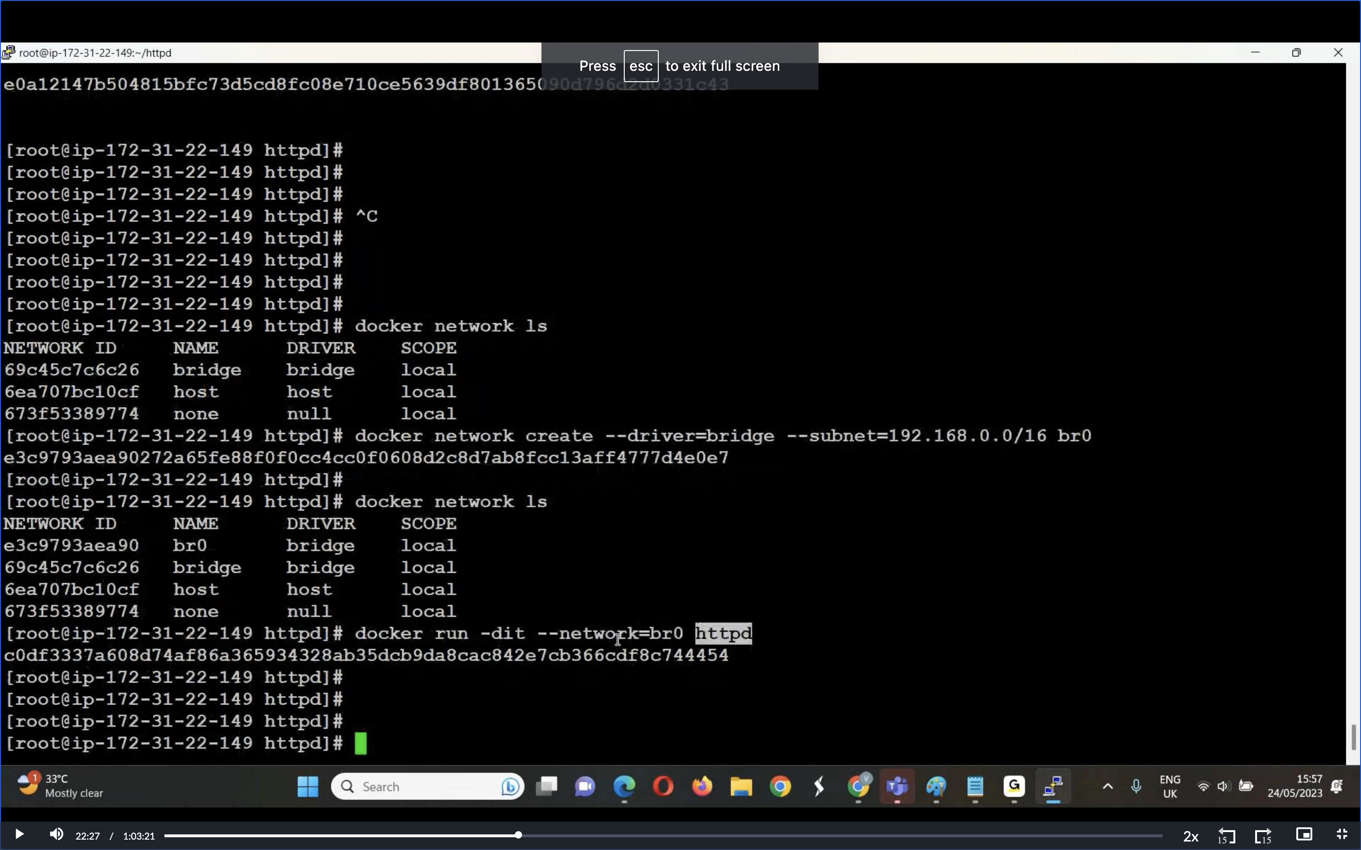

Showing two different networks created in the docker by default they don’t have any communication enabled between them

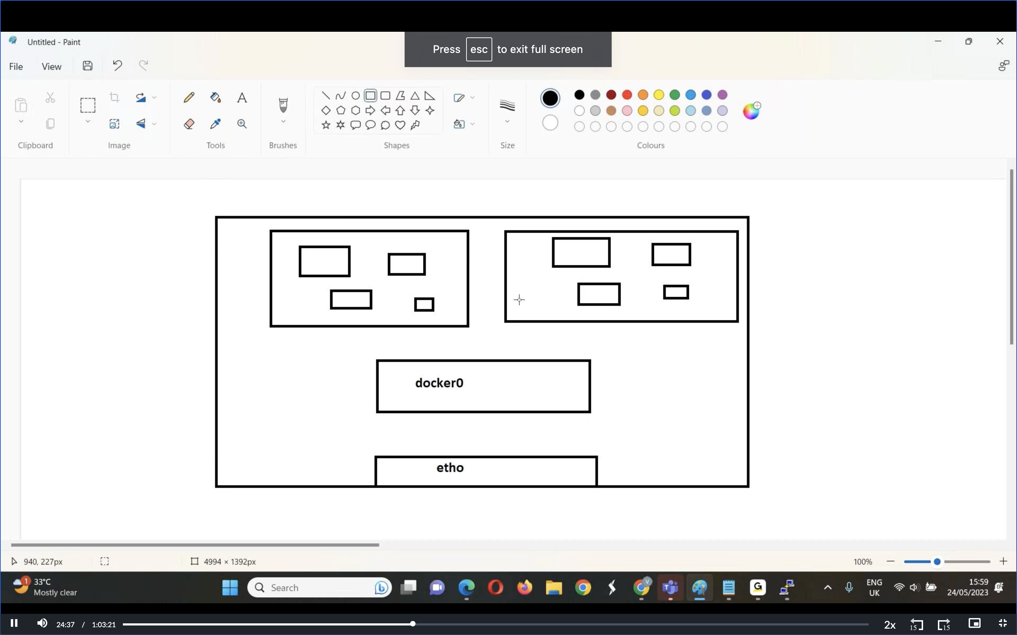

>docker run -dit -p 80:80 httpd

Here d is called detached mode and it is called interactive mode with out d it is called attached mode

We use attached mode for troubleshooting purposes

Different blw CMD vs ENTRYPOINT

We can override CMD commands but not the Entrypoint

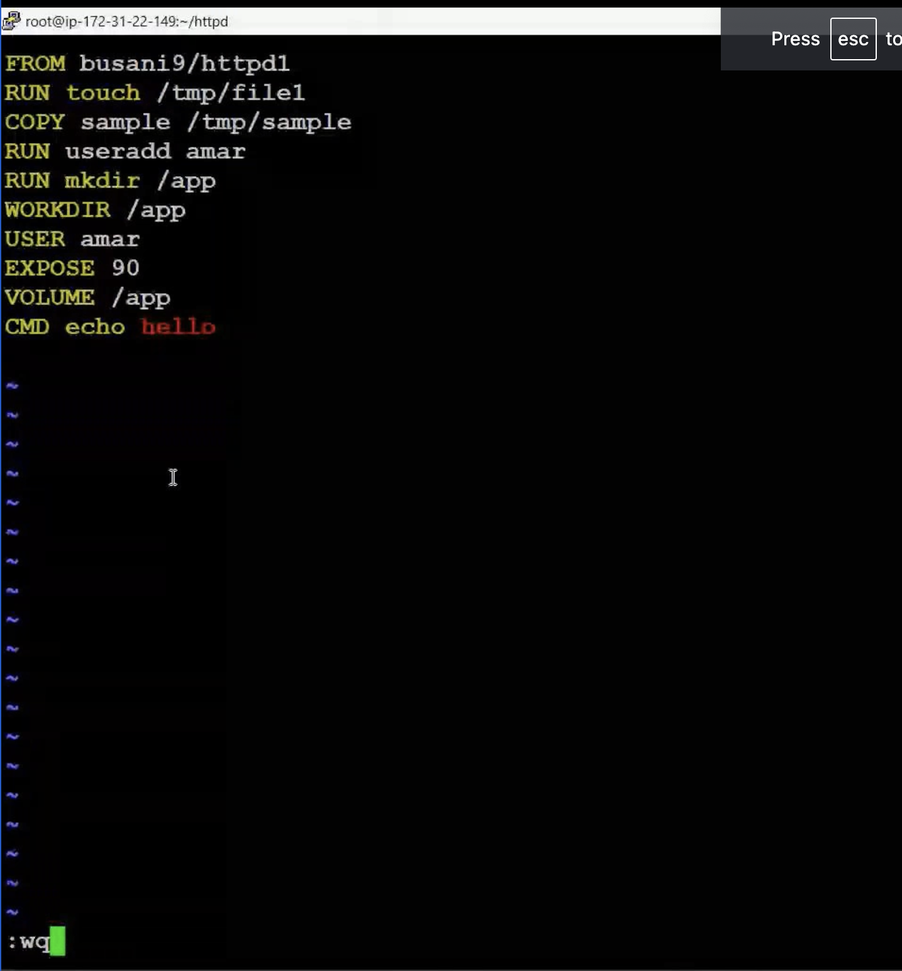

EXPOSE will giving information only about which port number shouldbe enabled it doesnot actually enable the port like in the

docker run -dit –name image_name -p 90:80 httpd

Docker Challenges

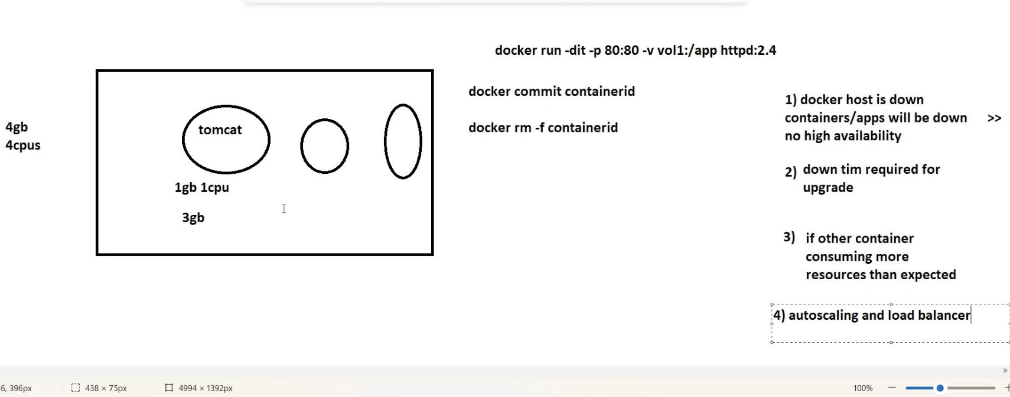

How to transfer docker image from one instance to another

